Stotes Hall Allotment Gardens Society

Guidance for Disposal of Waste and Rubbish
Please help to keep our gardens well-organised and free from weeds and rubbish. This list indicates the different categories of waste and where they go. Please do not leave waste in Natural Habitat or Communal Areas (see detailed Allotment Map on Page 2). Any questions or suggestions, please contact the Secretary, Ralph Pattisson (281 2131).
Non-organic waste
Plastics, metal, netting, plant pots, glass …
• Please take all unwanted material home (and reuse/recycle if possible).
• If you are not able to take it home, bins by the substation gate may be used (A).

Organic waste
- Wood/timber (branches, logs, boards etc):
• This is a valuable resource which we need for the bonfire, BBQ and oven.
• Please stack neatly in storage area at the bottom of allotments (behind large yew tree) (B).
• Only woody material suitable for the bonfire should be placed here – nothing else (no stalks, canes, brambles, small twigs, weeds etc).

2. Stalks/soft branches (raspberry canes, smaller twigs, brambles)
• This material is not suitable for allotment bonfire events.
• Please dispose of it on individual plots (long-term composting or burning: fires permitted between 1 November–31 March) or removed from the site.

3. Compostable material (grass, clods, sods, plants, some weeds)
• Please compost this material on your own plot
Advice on non-chemical weed control: https://www.rhs.org.uk/advice/profile?pid=343

4. Pernicious weeds: (mares tail, bindweed, Japanese knotweed)
• These serious weeds need to be disposed of safely by individual plot holders: burnt on the plot, removed completely from site, or placed in special labelled bins at the bottom of the allotments (behind large yew tree) (C). Do not compost.
• Mares tail are especially problematic (they spread by roots and spores).
• Japanese knotweed is a notifiable weed that requires different treatment. In first instance members should report its presence to the Secretary.

5. Dog waste: The nearest off-site litter bin (D on diagram) is confirmed as suitable by the council. Disposal anywhere on allotment site is prohibited.

Please see detailed Map on following page
indicating positions A, B, C and D

Stotes Hall Allotment Gardens Society
Natural Habitat Areas and Waste Management positions

MAP
Right side of map by main path: A (bins for non-organic waste)
Bottom of map: B (wood storage area) and C (bin for pernicious weeds)
Top of MAP: D (council bin on Jesmond Dene Rd, suitable for dog waste)
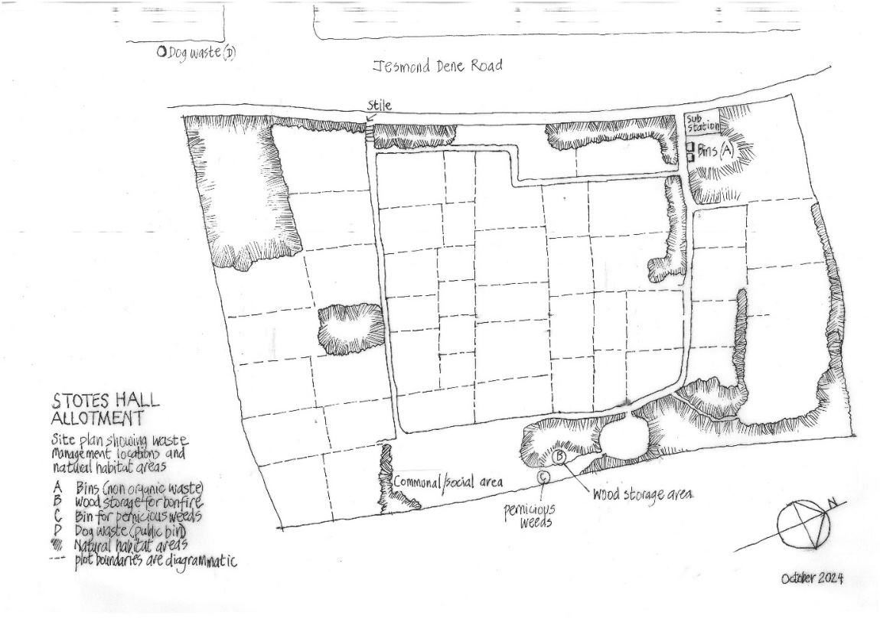

OUTLINE DIAGRAM

